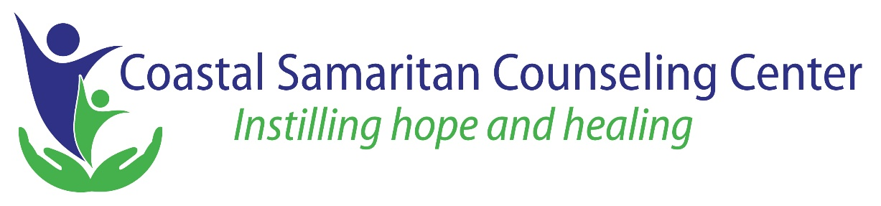

For Immediate Release Contact: Philip Keilen, Executive Director
June 21, 2021 (843) 448-4820 pkeilen@coastalsamaritan.org

Coastal Consulting, Inc. Founder Lauren Henson named Coastal Samaritan Counseling Center’s 2020 Heart of a Samaritan Annual Community Service Award Recipient

Coastal Consulting, Inc owner Lauren Henson has been recognized as the 2020 Heart of a Samaritan Award recipient by Coastal Samaritan Counseling Center (CSCC).

“Lauren Henson has served as President of the Board of Directors of Coastal Samaritan Counseling Center for the last three years and has set an extraordinary example of heartful service and practical experience for CSCC’s board and staff,” said The Reverend Hank Moody, current President of the Board of Directors. Henson has been involved with the center in some capacity for over 10 years.

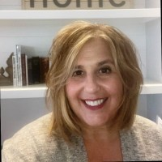
During the pandemic, Henson provided positive leadership and guided the transition from face-to-face therapy to video therapy. She also gave advice on the PPP bank loan process.

Philip Keilen, Executive Director of CSCC said, “Lauren Henson is the benchmark for board presidents during a crisis. Dedication, generosity of time and treasury, combined with her desire to make people’s lives better, is why she earned this award.”

CSCC helps people achieve wellness and wholeness by fostering hope and healing through professional counseling, consultation, and education. For more information about the center and The Heart of a Samaritan Award, or to make a donation, please visit www.coastalsamaritan.org.

901 N. Kings Hwy., Myrtle Beach, SC 29577
https://coastalsamaritan.org
csccinfo@coastalsamaritan.org
(843) 448-4820

