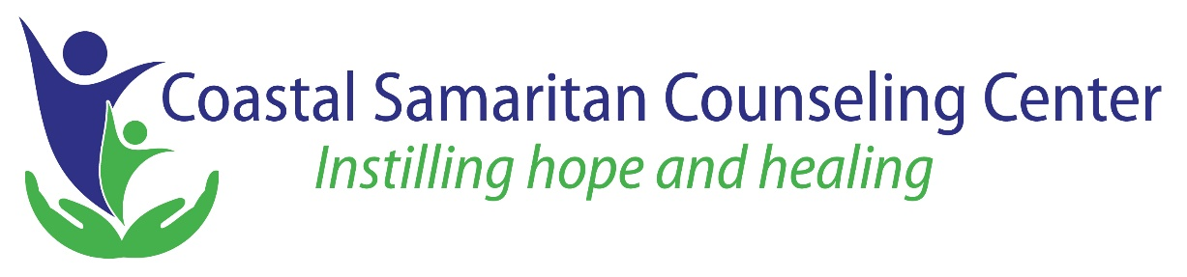

For Immediate Release Contact: Philip Keilen, Executive Director
February 9, 2021 (843) 448-4820 pkeilen@coastalsamaritan.org

Coastal Samaritan Counseling Center Welcomes New Board Members and Opens Office in North Myrtle Beach
On February 9, Coastal Samaritan Counseling Center welcomed Meredith Dark, Terry Kinard, and Tony Kyzer to its Board of Directors.
Kinard, a former free safety for the New York Giants, sees his involvement with the center as an opportunity to do positive things for the community. “I like helping those less fortunate in any way I can,” he said.
The center does not discriminate based on socioeconomic status. Grants and donations help the center provide affordable services for clients with limited means.
Kyzer, a self-employed structural engineer, has been an active participant in Lions and Rotary, as well as chairman of the board of North Myrtle Beach Christian School. “Since God has blessed me for a lifetime and has enabled me to serve effectively on boards of other Christian organizations, I felt led to make this commitment,” he said. “It is an honor to serve.”
Dark, a pastor at First United Methodist Church of Myrtle Beach, also looks forward to serving on the board. “Each day brings new challenges and opportunities. Individuals can practice their faith, receive counseling, and together these two can help bring about healing and wholeness.”
Coastal Samaritan Counseling Center has opened a new office in the North Myrtle Beach Business Center, which allows the center to serve the North Strand and Little River areas more effectively with appointments available Monday-Friday, 9 a.m.-5 p.m.
“The pandemic continues to affect our community in ways no-one could have anticipated. The mental health needs of children, adolescents, couples, families, health care professionals, caregivers, elderly persons, business owners, and church leaders is overwhelming,” said Philip Keilen, Executive Director. “Our center is well-equipped to help meet these needs.”
“Our counselors are professionally trained, experienced, and licensed as professional counselors; addiction counselors; clinical social workers; and/or marriage and family therapists. We are competent and specialized in a wide range of areas,” said Gina Barker, who specializes in trauma counseling.
Coastal Samaritan Counseling Center helps people achieve wellness and wholeness by fostering hope and healing through professional counseling, consultation, and education.

901 N. Kings Hwy., Myrtle Beach, SC 29577
https://coastalsamaritan.org
csccinfo@coastalsamaritan.org
(843) 448-4820

